**NAME : HAIDER REHMAN  
REG NO FA22-BSE-064**

**SDA PROJECT REPORT**

**PROJECT:**

**CAR RENTAL SERVICE**

**Full Use Case Diagram Of Project:**

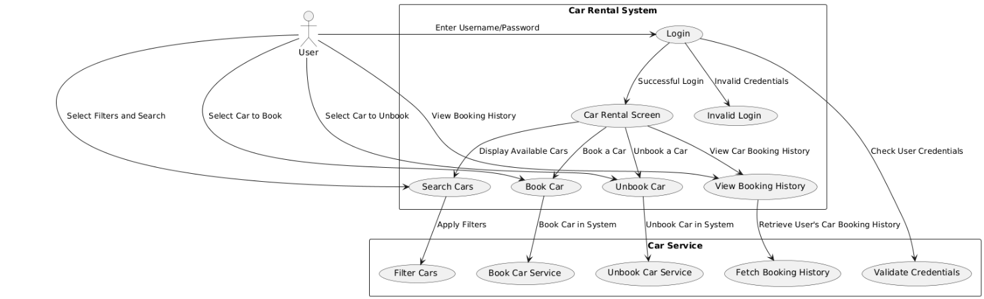

**My Selected Use Case:**

**Booked and unbooked car**

Use Case Diagram:

**Fully dressed use case**

Use Case 1: Book a Car

| Use Case | Book a Car |
| --- | --- |
| Primary Actor | User |
| Stakeholders and Interests | <ul><li>User: Wants to rent a car easily by selecting from available options.</li><li>Car Rental Service: Provides a seamless car booking process for its users.</li></ul> |
| Preconditions | <ul><li>The User has the application open and has selected a car from the list of unbooked cars.</li></ul> |
| Postconditions | <ul><li>The selected car's booking status is updated to "booked".</li><li>The car moves from the unbooked list to the booked list in the application UI.</li></ul> |
| Trigger | The User selects a car from the unbooked list and clicks the "Book Car" button. |
| Main Success Scenario | 1. The User selects an unbooked car from the list. 2. The User clicks the "Book Car" button. 3. The system verifies that the car is unbooked. 4. The system updates the car's status to "booked". 5. The car moves to the booked list. 6. The system displays a success message confirming the booking. |
| Extensions (Alternate Flows) | 3a. Car Already Booked - The system finds the car is already booked. - The system displays an error message: "The car is already booked!" |
| Special Requirements | <ul><li>The UI should visually distinguish between booked and unbooked cars (e.g., different background colors).</li><li>Only one car can be selected at a time from the list for booking.</li></ul> |
| Frequency of Occurrence | Regularly; whenever a user wants to book a car. |
| Open Issues | <ul><li>Possibility of adding a database to persist bookings across sessions.</li></ul> |

**Use Case 2: Unbook a Car**

| Use Case | Unbook a Car |
| --- | --- |
| Primary Actor | User |
| Stakeholders and Interests | <ul><li>User: Wants the ability to unbook a car if it’s no longer needed.</li><li>Car Rental Service: Provides flexibility for users to manage their bookings.</li></ul> |
| Preconditions | <ul><li>The User has the application open and has selected a car from the booked list.</li></ul> |
| Postconditions | <ul><li>The selected car's booking status is updated to "unbooked".</li><li>The car moves from the booked list to the unbooked list in the application UI.</li></ul> |
| Trigger | The User selects a car from the booked list and clicks the "Unbook Car" button. |
| Main Success Scenario | 1. The User selects a booked car from the list. 2. The User clicks the "Unbook Car" button. 3. The system verifies that the car is booked. 4. The system updates the car's status to "unbooked". 5. The car moves to the unbooked list. 6. The system displays a success message confirming the unbooking. |
| Extensions (Alternate Flows) | 3a. Car Not Booked - The system finds the car is not currently booked. - The system displays an error message: "The car is not booked!" |
| Special Requirements | <ul><li>The UI should visually distinguish between booked and unbooked cars.</li><li>Only one car can be selected at a time from the list for unbooking.</li></ul> |
| Frequency of Occurrence | Occasionally; whenever a user decides to cancel a booking. |
| Open Issues | <ul><li>Consider adding an option for users to confirm before unbooking.</li></ul> |

**Brief Use Case Diagram**

**Here’s how you could describe the use case diagram in the video or include it in your documentation:**

1. **Actors:**
   * **User: The main actor who interacts with the system to book and unbook cars.**
2. **Use Cases:**
   * **Book a Car: Allows the User to select and book an unbooked car.**
   * **Unbook a Car: Allows the User to select and unbook a booked car.**
3. **Relationships:**
   * **User has an association with both use cases, as they initiate both "Book a Car" and "Unbook a Car" actions.**

Sequence diagram:

DOWN ⏬⬇⤵🔽

State Machine Diagram:

DOWN ⏬⬇⤵🔽

Class Diagram:

**Package Diagram:**

**Communication Diagram:**

